Addis Ababa Full Day City Tours
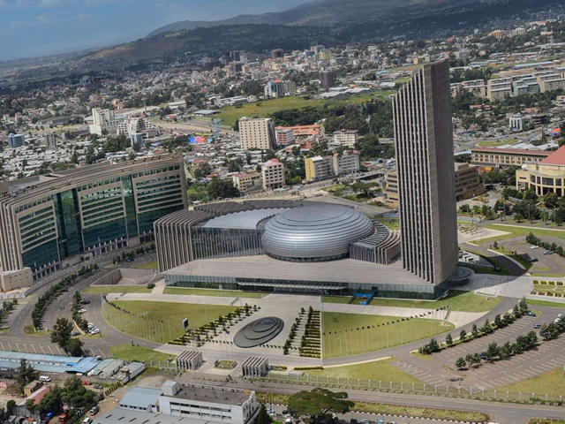
Duration 7-9 Hours
Mode of transportation: - Car
Addis Ababa City Tours
Addis Ababa (the name means 'new flower') is of fairly recent origin - Menelik founded the city in 1887. In this full day city tour you will visit different monuments and statue in the city
Entoto Hill (Amharic: እንጦጦ) - is the highest peak on the Entoto Mountains, which overlooks the city of Addis Ababa, the capital of Ethiopia. It reaches 3,200 meters above sea leve, it is a historical place where Emperor Menelik II resided and built his palace, when he came from Ankober and founded Addis Ababa. It is considered a sacred mountain and has many monasteries. Mount Entoto is also the location of a number of celebrated churches, including Saint Raguel and Saint Mary.
National Museum- also referred to as the Ethiopian National Museum, is a national museum in Ethiopia The museum houses Ethiopia's artistic treasures. It contains many precious local archaeological finds such as the fossilized remains of early hominids, the most famous of which is "Lucy," the partial skeleton of a specimen of Australopithecus aphaeresis. Recently added to the basement gallery is a display on Selam, found between 2000 and 2004. This archaic fossil is estimated to date to 3.3 million years ago.
Ethnological Museum -Set within Haile Selassie’s former palace, and surrounded by the beautiful gardens and fountains of the university’s main campus, is the enthralling Ethnological Museum. Even if you’re not a museum fan, this one is worth a bit of your time – it’s easily one of the finest museums in Africa, showing the full sweep of Ethiopia's cultural and social history across two floors.
Holy trinity Cathedral church- known in Amharic as Kidist Selassie is the highest ranking Ethiopian Orthodox Tewahedo cathedral in Addis Ababa, Ethiopia. It’s the burial place for those who fought against the Italian Occupation, or those who accompanied the Emperor into exile from 1936 to 1941. Emperor Haile Selassie I and his consort the Empress Menen Asfaw are buried in the north transept of the cathedral. Other members of the Imperial Family are buried in the crypt below the church
Merkato- መርካቶ for "New Market", popularly just Merkato, from the Italian for "market") is the name for the large open-air marketplace in the Addis Ketema district of Addis Ababa, Ethiopia, and for the neighborhood in which it is located.

